

|  |
| --- |
| Apparel & Footwear |
| **UDF Creation and Update** |
| Argentis Consulting |



**www.argentisconsulting.com**

**UDF Creation Process for the PDM Console.**

The following steps describe the creation of UDF for the PDM console in Apparel and Footwear.

To create the UDFs on Apparel and Footwear please follow the steps:

1. First we need to create the UDF on the User Tables, to do this, on SAP, go to Tools 🡪 Customization Tools 🡪 User-Defined Fields – Management…

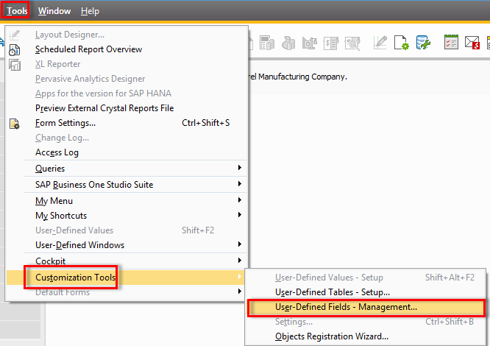

1. Look for the User Tables and open the content by clicking on the black arrow on the left of the text.

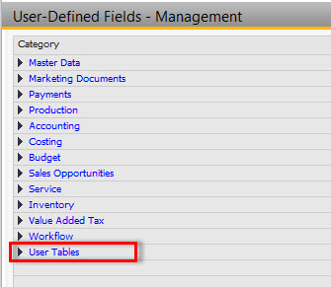

1. Look for the table called Argentis Model (this table is the one that we use to manage the Product Data Management console), select it by clicking over it and click on the “Add” button.

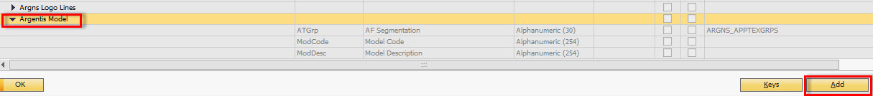

1. Complete the information requested according to the needs and select “Add” to create it.

The UDF must begin with **ARGNS**

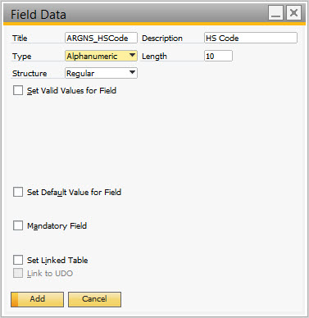

1. No we must create the UDF on the Master Data tables, to do this look for the Master Data 🡪 Items 🡪 Items, select this last one, by clicking over it and select “Add”.

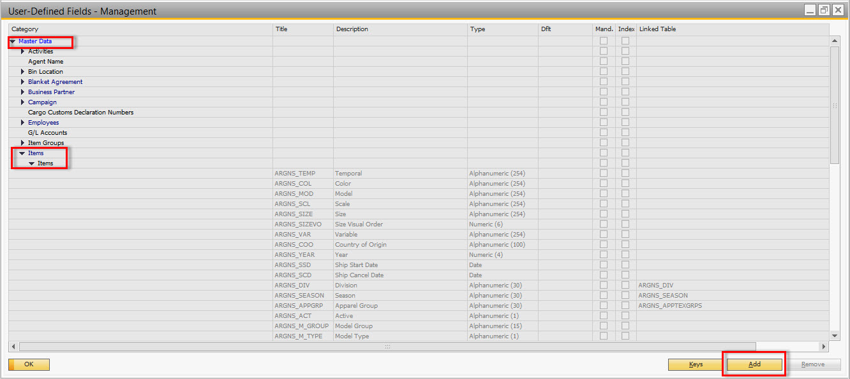

1. Make the UDF exactly as the one created on the User Table.

The UDF must begin with **ARGNS**



1. If you go to the PDM Console on Apparel and Footwear and select the UDF tab you should now see the new created UDF.

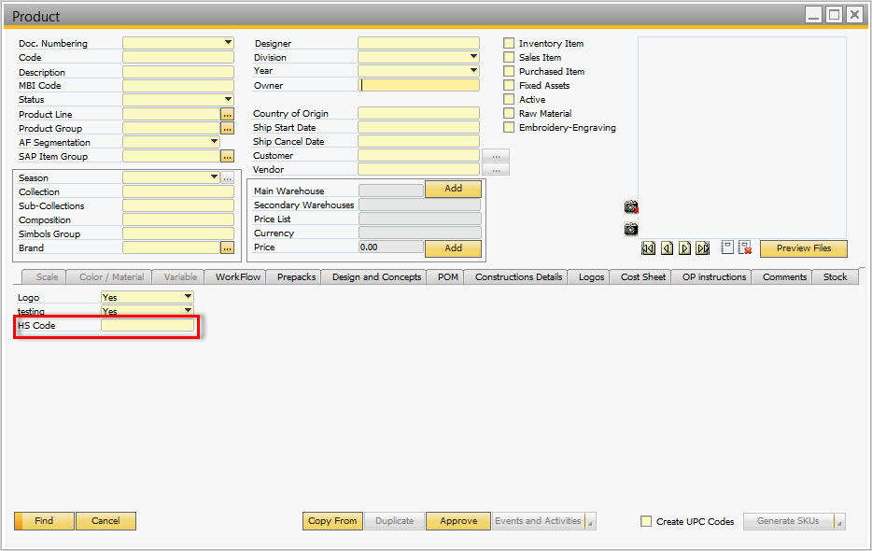

**UDF Options update Process for the PDM Console.**

The following steps describe the creation of UDF for the PDM console in Apparel and Footwear.

To create the UDFs on Apparel and Footwear please follow the steps:

1. First we need to create the options on the UDF on the User Tables, to do this, on SAP, go to Tools 🡪 Customization Tools 🡪 User-Defined Fields – Management…



1. Look for the User Tables and open the content by clicking on the black arrow on the left of the text.



1. Look for the table called Argentis Model (this table is the one that we use to manage the Product Data Management console), look for the UDF field you want to add or modify options to, in my example, HS Code, select it by clicking over it and click on the “Update” button.

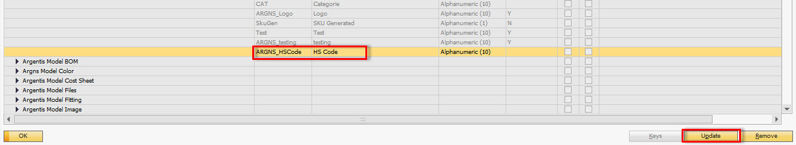

1. Make sure the “Set Valid Values for Field” and click on the “New” button for each option you want to add. You may check the “Set Default Value for Field” checkbox if you want a default value to appear when you open a model. Once finished click “OK” and accept the warnings you get.

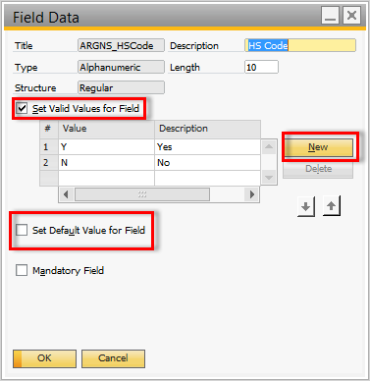

1. If you open a PDM window on Apparel and Footwear you should now see the UDF with the new options.

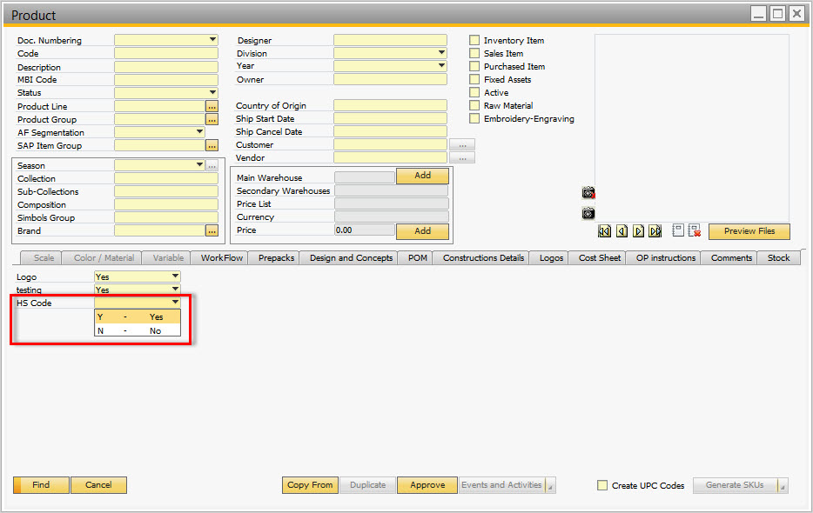



**www.argentisconsulting.com**

|  |  |
| --- | --- |
| **USA**  9744 NW 45th Lane  Doral, FL 33178  info@argentisconsulting.com | **ARGENTINA**  Ávila y Zarate 2048  Cerro de la Rosas, Córdoba,  CP 5009  Córdoba - Argentina  info@argentisconsulting.com |
| **CARIBEAN**  City View Plaza – Suite 301  48 Road 165  Guaynabo, PR. 00968  Puerto Rico  caribe@argentisconsulting.com | **SPAIN**  C/ Juan Bravo N° 3 A 28006  Phone: (+34) 91 123 7263  Madrid - Spain  info@argentisconsulting.com |

**INFORMACIÓN DE CONTACTO**

**Argentis Consulting** is dedicated to the development, distribution   
and support of recognized certified solutions for SAP Business One.   
As an SAP Software Service Provider Partner with Gold Status.